Sweep Requests from PAR

Overview

Current processing
There is no Sweep from PAR functionality available for Old BOB classes

New requirement
The requirement below applies to handling of different Sweep requests from PAR workstation for New BOB/SPX Linkage.
- For Sweep and Return --
  - Trade and link out everything that is one penny better the Sweep price (Execution Price provided by PAR) and then at last trade only Customer in the CBOE book at that Sweep price, once the Sweep and link processes completes return the Order to PAR if any quantity left.
- For Sweep and Route --
  - If CBOE is NBBO, then take the price one penny better than BOTR price and use that price for trading, once the Sweep process completes return the Order to PAR if any quantity left.
  - If CBOE is not NBBO, then take the price one penny better than CBOE BBO and use that price for linking out and save this price, once the Sweep and link processes completes use the saved price to trade any Customer Order in CBOE book if this saved price is still the BBO and then return the Order to PAR if any quantity left.

Assumption
- Trading Class will be enabled for New BOB (SPX Linkage) functionality.
- New HAL will be “ON”.
- PAR will send this request with Execution Price and volume to be used as Sweep price and volume.
For detail please refer to Requirement document.

Implementation
Handling of Sweep & Return Logic
- Take the Execution price from Handling Instruction and make it penny better.
- Pass this penny better price to Sweep service as trade ending price.
- Sweep service will use this price to trade and auto link to away exchanges.
- And then will try to trade Customer Order in the CBOE book (if any quantity available) at the execution price.
- If Order was auto linked, once it comes back sending it back to originating PAR (if any quantity left).

Handling of Sweep & Route Logic
- Check to make sure not more than one away Exchange available in the list of Away Exchanges.
- If CBOE is NBBO, then take the BOTR price make it penny better and send the better price comparing with Execution price from Handling Instruction, try trading internally in CBOE using this price.
- If CBOE not NBBO, then take the penny better price of CBOE BBO and send the better price comparing with Execution price from Handling Instruction, try auto linking with this price to Away Exchange for the full quantity provided in Handling Instruction, at the same time save this BBO price.
- Once the Auto linked Order comes back if any quantity left and CBOE BBO price is still the same as saved BBO price then trade the Customer Orders on that BBO price.
- Send back to originating PAR (if any quantity left).

The new classes are listed below that will be implemented for this functionality; BrokerStrategyFactory will be modified to find these newly implemented Strategy classes:
- BrokerNewBOBSweepReturnStrategy – Used to handle Sweep and Return request coming from PAR for that Order.
- BrokerNewBOBSweepRouteStrategy – Used to handle Sweep and Route request coming from PAR for that Order.

Main Flow
- All Order for New BOB Class/SPX Linkage will be accepted through acceptOrder() of OrderRoutingDestinationImpl.
- The Order will propagate through and follow common path of BrokerServiceImpl and BrokerImpl.
- After that, Product state check will be done and for appropriate product states (i.e. OPEN and FAST) will proceed to grab the Class/Product level lock.
- After the lock, the request will invoke AcceptOrderCommand that in turns will call processOrder(Order anOrder) on BrokerProcessorHybrid2Impl.
- This will find the right Strategy to process the Order.
- If the Order has HandlingInstruction as TradingRestrictions.SWEEP_AND_RETURN:
  - BrokerNewBOBSweepReturnStrategy will process the request.
  - This strategy will make the Execution price penny better and will call doNewBOBSweepAndReturn()on BrokerProcessorHybrid2Impl.
  - That will call processSweep() on SweepEvaluationServiceImpl for trading and auto linking.
  - If any quantity still left will be used with the Execution price and call tradeCustomerLikeOnly() on BrokerNewBOBSweepReturnStrategy that in turns will call BrokerProcessorHybrid2Impl. tradeWithNonQOnly() with customer only true for trading.
  - At the end if nothing shipped out and still quantity left then return to PAR using doPostProcess().
- If the Order has HandlingInstruction as TradingRestrictions.SWEEP_AND_ROUTE:
  - BrokerNewBOBSweepRouteStrategy will process the request.
  - Check if only one away Exchange using isOnlyOneExchange(), if not true then return to PAR.
  - If CBOE NBBO, then call processInternalSweepTradable() on BrokerProcessorHybrid2Impl using price penny better then BOTR and comparing with Execution Price on HandlingInstruction and taking better among these two and try trading internally in CBOE book using processInternalSweep() on SweepEvaluationServiceImpl.
  - If CBOE not NBBO, then call doNewBOBSweepAndRoute() on BrokerProcessorHybrid2Impl using price penny better then CBOE BBO price and comparing with Execution Price on HandlingInstruction and taking better among these two and try to auto link using processAutoLink() on SweepEvaluationServiceImpl.
  - Now save the BBO price on Order context and wait for linked request to come back.
  - Once the liked request comes back through acceptAutoLinkReturnedRemainder() of OrderRoutingDestinationImpl it reaches to AcceptAutoLinkReturnCommand using appropriate strategy.
  - Here it will take out the saved BBO price from Order context and compares with current BBO price, if both are same – then it will try to trade any Customer Order in the CBOE book using tradeWithNonQOnly() on BrokerProcessorHybrid2Impl at that price only.
  - At the end clears any saved BBO price from Order context and returns Order to originating PAR (if any quantity left).

Scripts
- None

Database
- None

SetContext

XML/DTD

Homes/Services
- BrokerNewBOBSweepReturnStrategy
- BrokerNewBOBSweepRouteStrategy

ImplPlan
- Sequence Diagram (Sweep & Return)
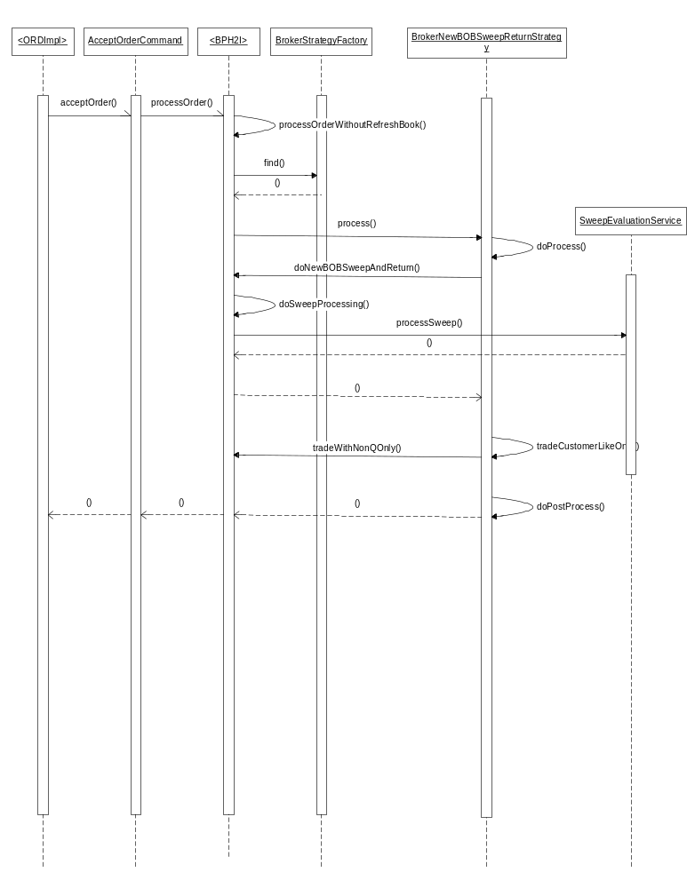

- Sequence Diagram (Sweep & Route)
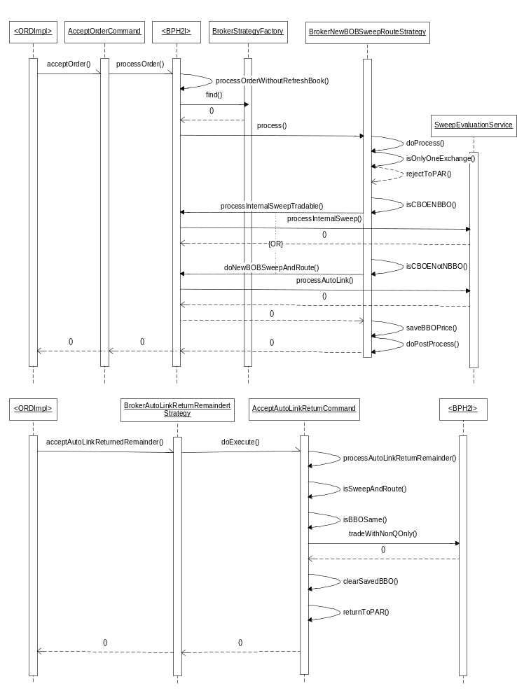

PerformanceTestingProcedure
- .

TestingProcedure

OperatorProcedure
- .

Fallback/Failover

